Salmon Habitat Mapping in the Central Kenai Peninsula 2021-2025 [DRAFT]

Benjamin Meyer, Kenai Watershed Forum

2025-12-01

# 

# Executive Summary

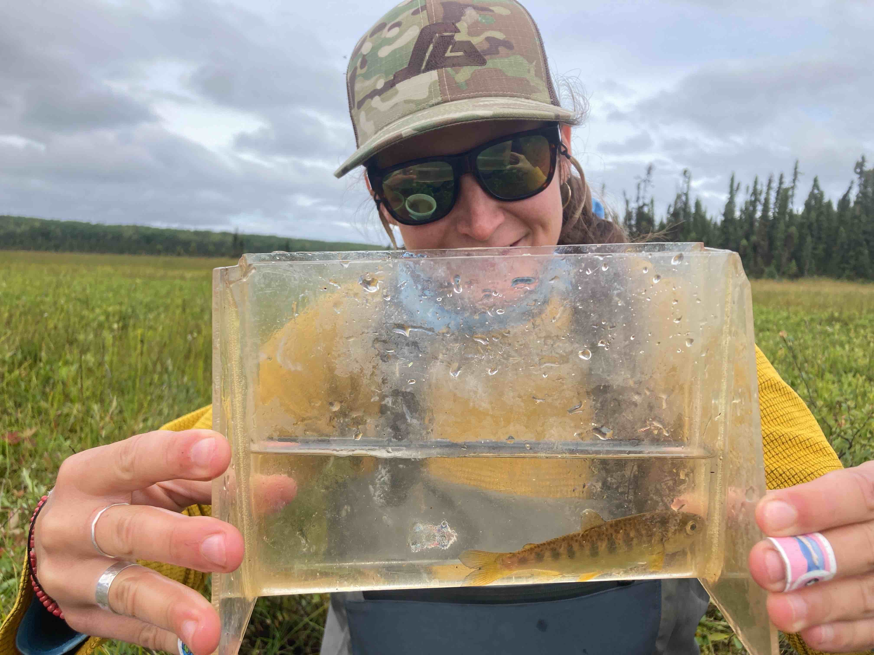

|  |  |
| --- | --- |
|  | It is estimated that less than half of Alaska’s freshwater salmon habitat is officially documented by the Alaska Department of Fish and Game, and until these streams and lakes are inventoried they will not be afforded certain protections under Alaska state law.  Nonprofits in the central Kenai Peninsula regio including Kenai Watershed Forum, Cook Inletkeeper, and the Kenai Peninsula Chapter of Trout Unlimited are collaborating to address this data gap by working with volunteers to document local salmon habitat. From 2021 - 2025, we identified 24.5 miles of stream and 173 lake acres of previously undocumented anadromous habitat near the roadways of the Kenai Peninsula.  Given that so much undocumented salmon habitat was so close at hand prior to this project, our results highlight the need to continue this work and explore new methods of mapping and modeling that can address the scale of the challenge. Going forward in summers 2026-2027, we are working with geospatial specialists to apply predictive habitat occupancy models that will help to target and prioritize our fieldwork. If these models prove successful, we anticipate that in the future they may have broad application throughout Alaska, for researchers as well as within regulatory and permitting regimes.  Access the online interactive map of results at <http://bit.ly/kwf_awc>. |

Our work is funded from the following sources:

* [National Coastal Resilience Fund](https://www.nfwf.org/programs/national-coastal-resilience-fund) grant (2025 - 2027)
* [Trout Unlimited Embrace-a-Stream](https://www.embraceastream.org/) grant program (awards in 2019 and 2023)
* [Kenai Community Foundation](https://www.kenaicommunityfoundation.org/) grant program (award in 2019)
* [Alaska Sustainable Salmon Fund](http://www.akssf.org/About.aspx) project #54014, “Expanding and Corroborating the Known Extent of Anadromous Waters Throughout the Kenai Peninsula” (Award 2021 - 2023)
* [Kenai Peninsula Chapter of Trout Unlimited](https://kenaipeninsula.tu.org/)

### Notes on Previous Versions of this Report

This document serves as the final report for work conducted from 2021 - 2025 to expand and corroborate the Alaska Department of Fish and Game’s Anadromous Waters Catalog in the central Kenai Peninsula area of Alaska, USA.

This document combines, replaces, and updates the following two previous reports, which can be disregarded as earlier versions:

* <https://bookdown.org/kwfwqx/tu_awc_expansion/>
* <https://bookdown.org/kwfwqx/awc_expansion/>

# 1. Introduction

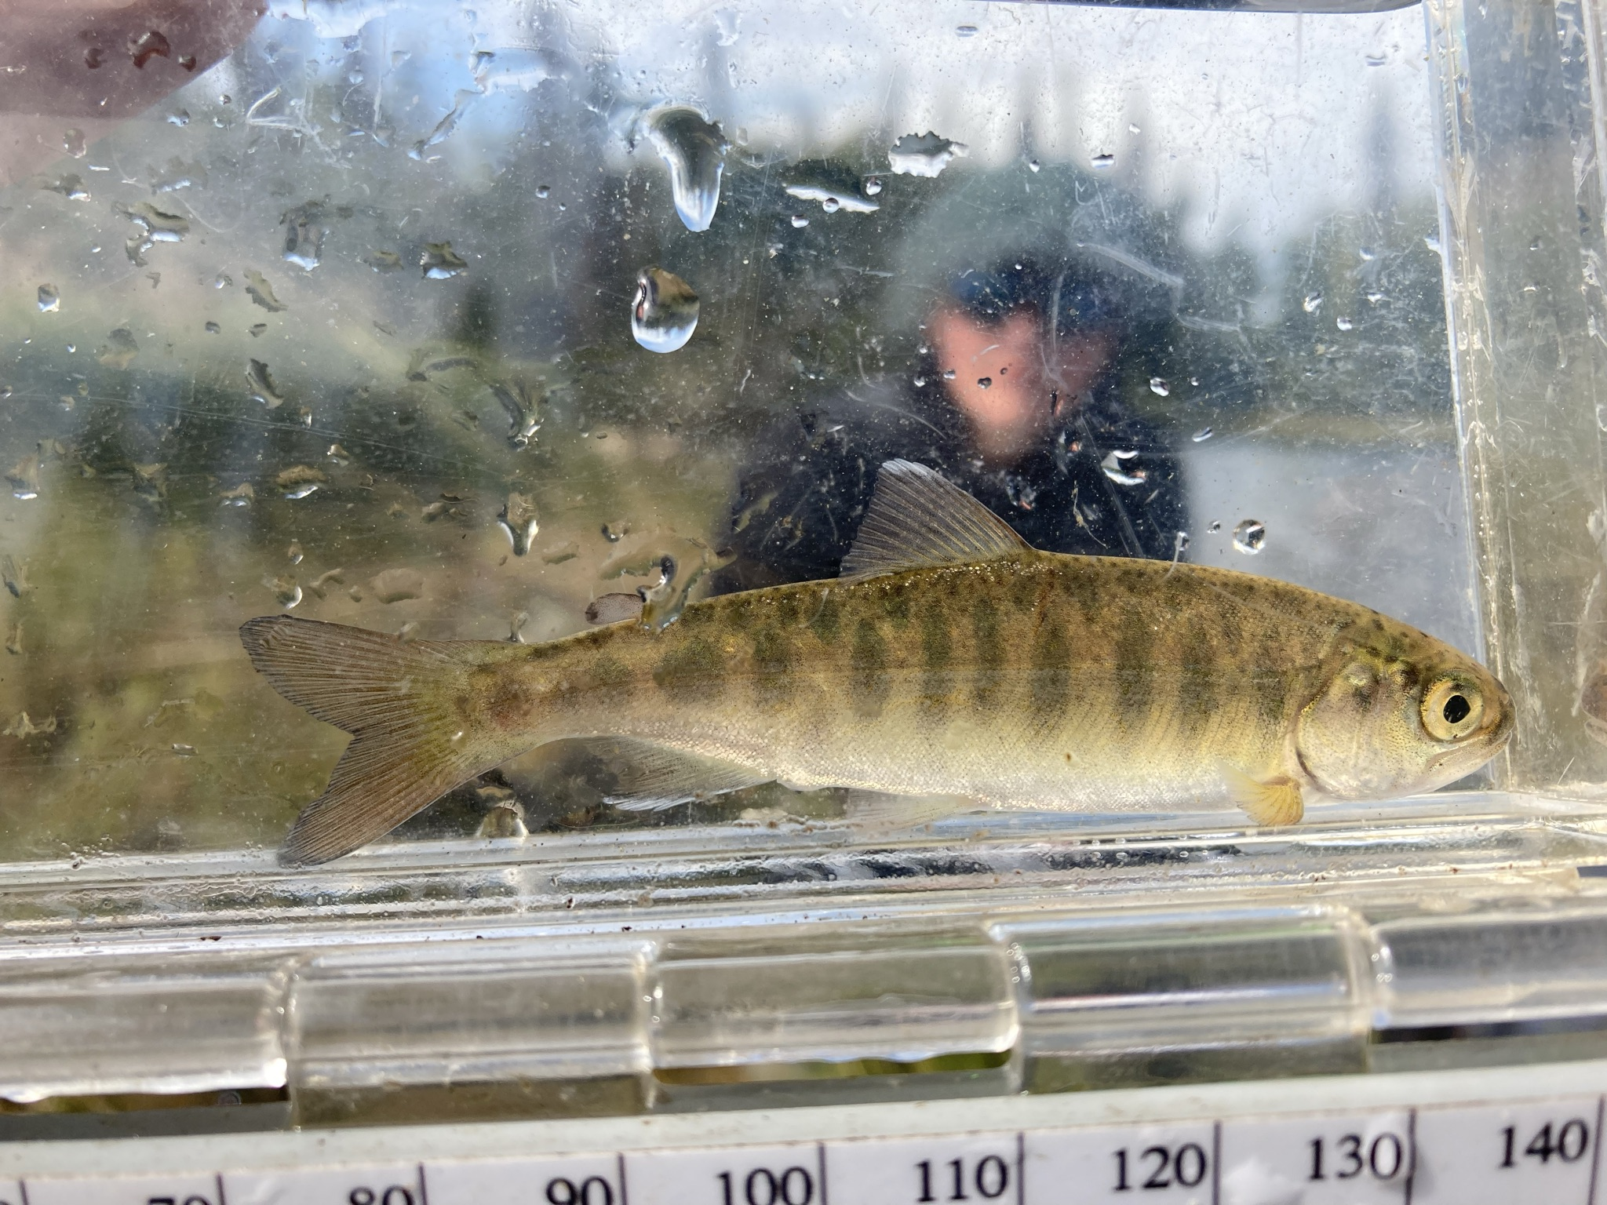

Juvenile Coho Salmon

## 1.1 Project Rationale

|  |  |
| --- | --- |
|  | The Kenai Peninsula’s watersheds are significant producers of Pacific salmon. Critical to Alaska’s economic and cultural wellbeing, these salmon support fisheries both inland and throughout Cook Inlet. [Kenai Watershed Forum](https://kenaiwatershed.org/) (KWF) in collaboration with [The Kenai Peninsula Chapter of Trout Unlimited](https://kenaipeninsula.tu.org/) (KPTU) are documenting habitat for salmonid spawning, rearing, and migration in order to increase the known water bodies recognized in the Alaska Department of Fish and Game’s (ADF&G’s) Anadromous Waters Catalog (AWC). The AWC is Alaska’s most powerful tool for regulating, protecting, and conserving anadromous fish habitat statewide. |

Salmon are intrinsic to the cultural and economic well being of Alaska, but cannot persist on the landscape without healthy habitat. Through strategic conservation efforts, riparian and instream habitat can continue to maintain salmon populations as well as transport marine-derived nutrients; maintain hydrology; and provide refuge during a rapidly changing climate.

In recognition of the importance of protecting anadromous fish habitat, the State of Alaska enacted [Alaska Statute 16.05.871](http://www.adfg.alaska.gov/index.cfm%3Fadfg=habitatregulations.prohibited)[1], “Protection of Fish and Game”, which requires the state to list rivers, lakes, and streams important for the spawning, rearing, or migration of anadromous fish, while also requiring the prior approval of construction or use of said waterbody that may result in adverse effects on salmon populations. In response, ADF&G began overseeing the AWC whose data is now publicly hosted online for resource managers and interested members of the public to utilize. See Figure Figure 1.1 for ADFG’s online interactive map these data. Access the map at <https://bit.ly/awc_map>.

|  |
| --- |
| Figure 1.1: The Alaska Department of Fish and Game’s Anadromous Waters Catalog online mapper. |

Each year, ADF&G solicits anadromous stream nominations from statewide efforts from the previous year. Once accepted, these nominations are incorporated into the AWC and its associated atlas. To date, [the AWC includes nearly 20,000 anadromous streams, rivers, and lakes](https://www.adfg.alaska.gov/sf/SARR/AWC/index.cfm?ADFG=main.home)[2], though it is widely understood that this number represents [less than fifty percent](https://www.adfg.alaska.gov/sf/SARR/AWC/index.cfm?ADFG=nomSubmit.about) of anadromous waterbodies throughout the state[3]. While ADF&G is conducting efforts to update existing data and survey for previously undocumented habitat, there remains a vast number of water bodies in need of surveying and habitat use observations.

In response, this project proposed to collect new observations of fish habitat and submit them for inclusion in the AWC. In 2025 we expanded the project scope to focus on developing an “end of anadromy” model for the Kenai Peninsula region, supported by fieldwork validation.

IN 2021 - 2023 KWF worked with KPTU to strategically prioritize survey sites to collect data for AWC nomination submissions. Site prioritization was based on criteria including the increase in protected anadromous fish habitat, accessibility, and alignment of priorities with local agency and partnership goals. These are described in greater detail in the methods section. KWF coordinated with local agency partners to ensure that fieldwork efforts were not unnecessarily replicated.

### 1.1.1 Anadromous Habitat Modeling

In response to the challenging scale of the task of ground-truthing many thousands of miles of anadromous streams, we are investigating methods to model probable anadromous habitat. If successfully developed, we anticipate that future managers and researchers will be able to consult these maps when reviewing permit applications, assessing habitat, or other applications.

Following methods described in Romey and Martin 2022 and others, in 2024 we applied existing end-of-anadromy modeling techniques to areas within the boundaries of the Chugach National Forest, where sufficient supporting geospatial data currently exists[4]. We report on these initial efforts in the Discussion section of this report. We are continuing and refining this approach 2025 -2027 with support from the National Coastal Resilience Fund.

## 1.2 Volunteer Training

In summer 2021 a half-day training workshop was conducted by Kenai Watershed Forum staff for fifteen Trout Unlimited volunteers, including but not limited to identifying ideal anadromous fish habitat; responsible deployment and retrieval of minnow traps; juvenile and adult fish identification; data collection and recording while in the field; and safe travel in bear country. Participants were introduced to an [Anadromous Habitat Survey Standard Operating Procedure](https://bit.ly/kwf_awc_sop) (SOP) document[5]. In summers 2022 - 2024, volunteers instead received training hands-on during fieldwork activities.

In summer 2025 KWF began coordinating with Cook Inletkeeper to expand public participation and outreach efforts under the “Backyard Salmonscapes” Local Solutions program.

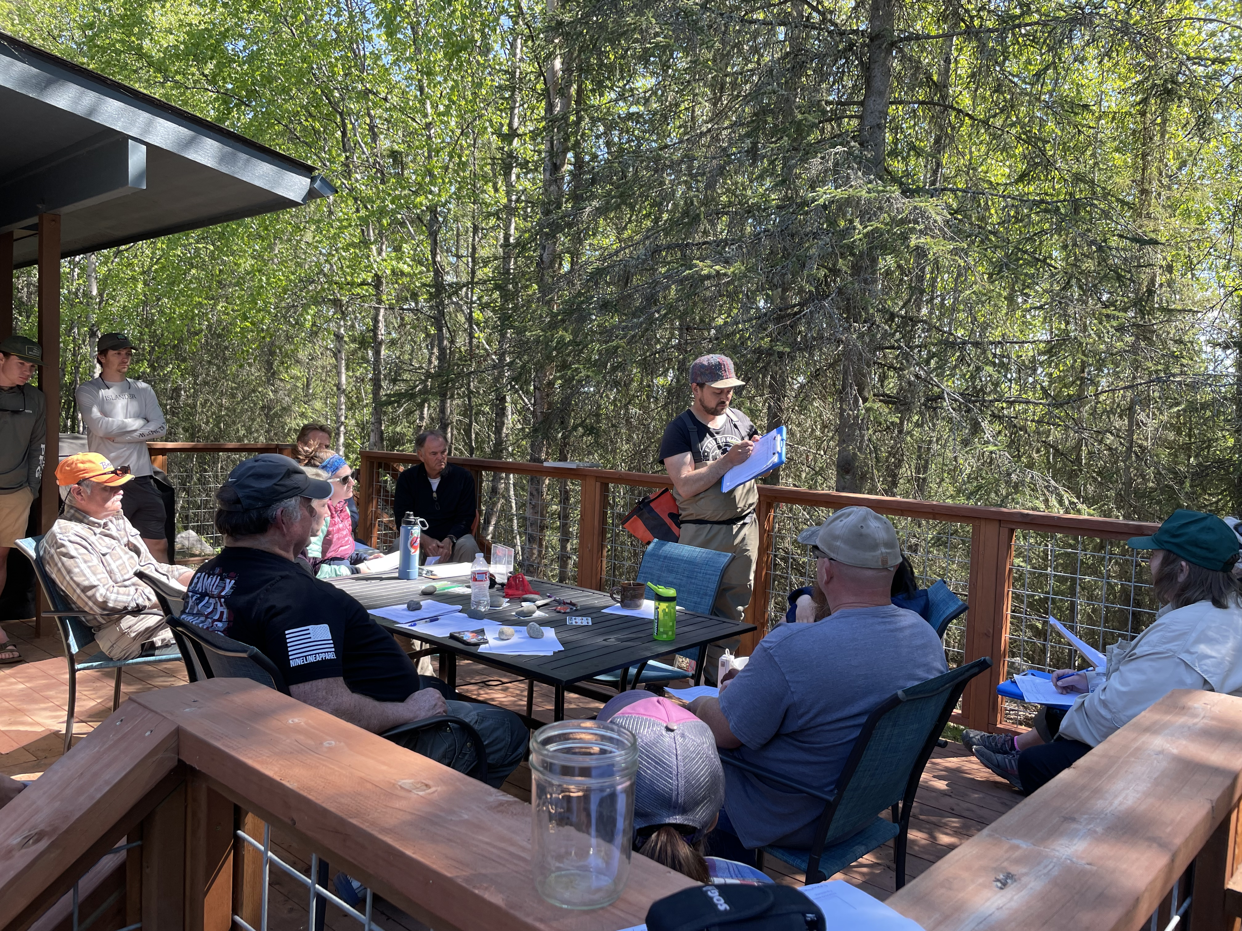

Kenai Peninsula Chapter of Trout Unlimited Volunteers.

## 1.3 Objectives

* Submit nominations to increase anadromous stream, river, lake, and wetland coverage in the AWC and corresponding atlas
* Revise or corroborate outdated AWC and atlas data, particularly on Kenai River tributaries experiencing increases in zinc concentrations as well as priority corridors identified by the Kenai Mountains to Sea partnership
* Explore the feasibility of applying predictive modeling techniques for anadromous habitat within the Kenai Peninsula Borough

# 2. Methods

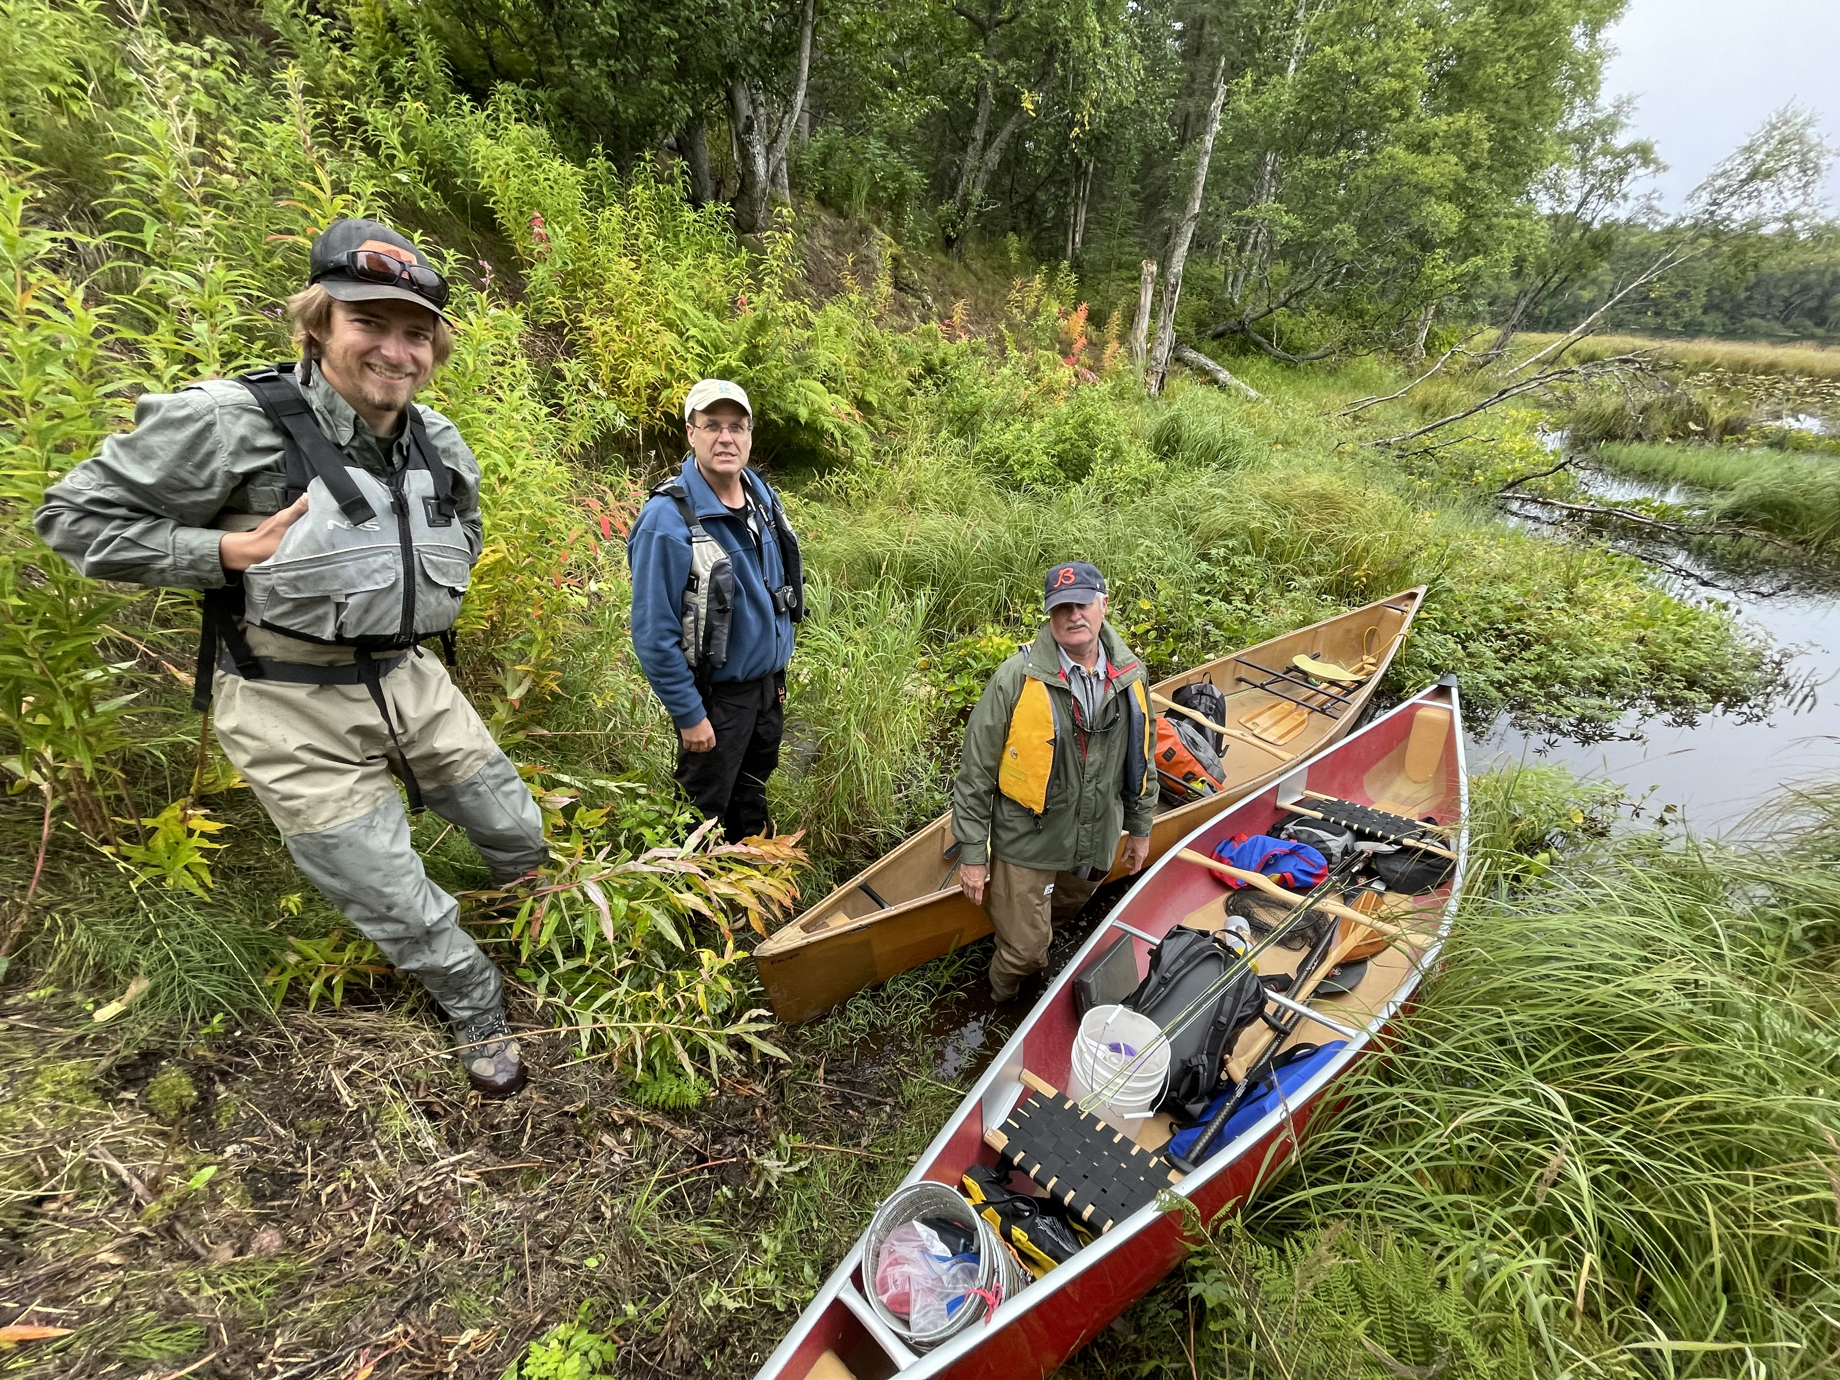

Kenai Peninsula Trout Unlimited volunteers preparing for fieldwork at Suneva Lake in August 2021.

## 2.1 Site selection

Fish habitat survey sites were identified using databases generated by Kenai Peninsula Trout Unlimited and Kenai Watershed Forum. Sites were further prioritized using the following criteria:

* Significant increase in protection of anadromous fish habitat through addition of new stream miles/lake acreage
* Ability to provide significant revision and/or data corroboration for outdated catalog data
* Ease of accessibility via foot travel based on travel time and ability to obtain private property access
* Proportion of stream or lake adjacent to developed parcels
* Habitat with medium-high risk assessment rating using the [Kenai Peninsula Fish Habitat Partnership’s “Freshwater Potential Threats Ranking Table](https://www.kenaifishpartnership.org/wp-content/uploads/2013/06/DRAFT-Freshwater-CAP_2014_solicitation.pdf)“[6]
* Alignment with fieldwork priorities of local resource managers as well as partnership efforts including those of Kenai Mountains to Sea (a prioritized corridor list can be found at <https://kenaiwatershed.org/science-inaction/mountains-to-sea/>) and Kenai Peninsula Fish Habitat Partnership (KPFHP)

### 2.1.1 Online Project map

The project map may be accessed by following the link at [ArcGIS Online](https://experience.arcgis.com/experience/806e59bc0eac4713a26f1f03a76cf85a/)[7] or in the interactive figure in the web version of this report. Toggle layers on/off as needed.

Prior to minnow trap deployment or use of backpack electrofishers, each year we obtained all necessary agency permits from ADF&G, USFWS, USFS, and others. As required by the Alaska Department of FIsh and Game’s (ADF&G’s) Aquatic Resource Permit, the ADF&G local Area Management Biologist was notified of fish survey locations and timeframes before going into the field. We also obtained landowner permission for access to sites where applicable. Finally, trapping efforts for each day were strategically chosen based on proximity of sites so as to reduce drive and personnel time.

## 2.2 Fish capture and processing

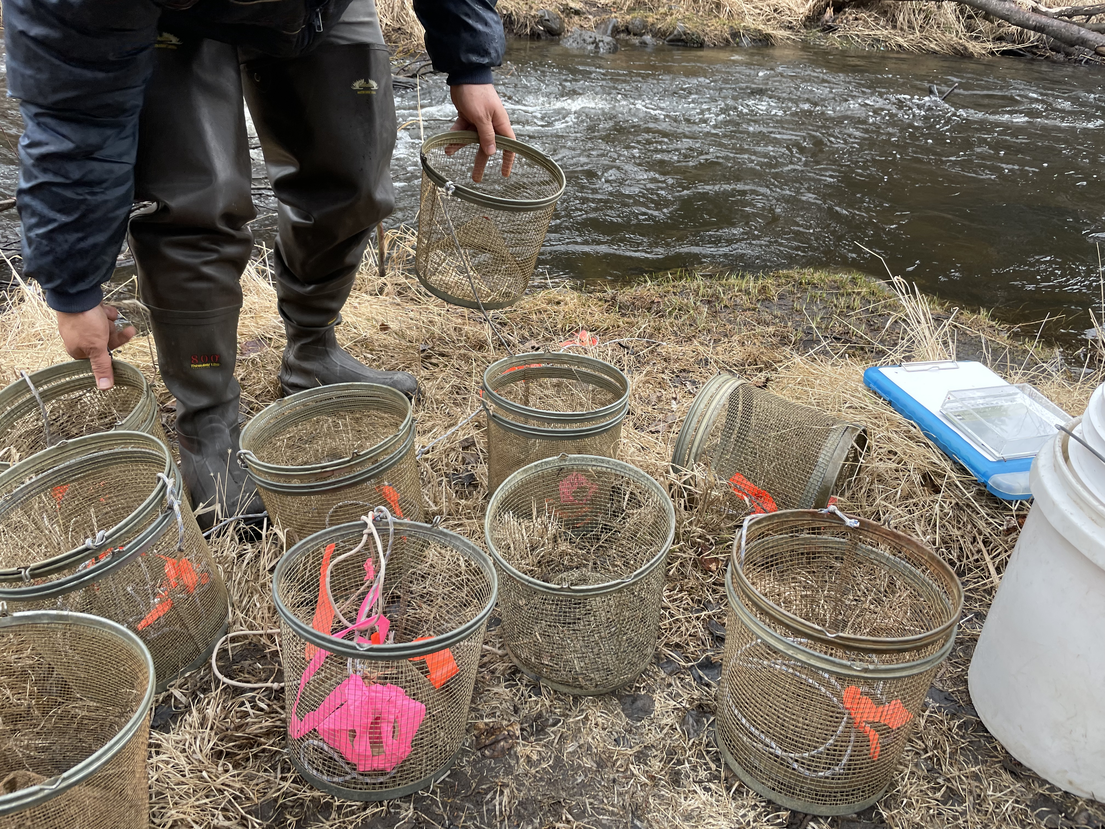

Minnow traps being prepared at by Trout Unlimited volunteers at a training workshop at Soldotna Creek in June 2021

### 2.2.1 Minnow Trapping

We used Gee minnow traps baited with salmon eggs as the primary capture methods for juvenile salmonids. We used commercial salmon eggs as bait and placed them in perforated 2-4 oz containers in order to prevent egg consumption by fish. We labeled traps with KWF contact information using brightly colored flagging tape. At the trapping location, we collected site photos and recorded the following on a datasheet: field technician initials, GPS coordinates of trap deployment site(s), and site drawings with pertinent notes regarding fish habitat. We used a minimum of one baited minnow trap, fully submerged in a discrete location, and properly secured to ensure retrieval. We recorded the date and time of deployment. While not exceeding 24 hours, we allowed traps to soak overnight if needed. Upon trap retrieval, we recorded the date and time and transferred the trap’s catch into a bucket of water.

### 2.2.2 Backpack Electrofishing

We used electrofishing: single pass techniques to survey for end-of-anadromy locations (Penaluna et al. 2021). We electrofished to delimit last-fish using a spatially continuous, single-pass backpack electrofishing approach similar to that described by Torgersen and validated by Bateman, but sampled all accessible stream habitat (Bateman, Gresswell, and Torgersen 2005; Torgersen, Gresswell, and Bateman 2004). We optimized electrofishing effectiveness so that units are set at the minimum needed to achieve satisfactory electrofishing in each stream (Reynolds and Harlan 2011). Detections with electrofishing were made visually by identifying individual fish to the lowest taxonomic unit possible, which was generally to species.

### 2.2.3 Fish processing

We identified each fish that we captured to lowest feasible taxa and life stage using a photarium. We recorded disposition; and in some cases recorded fork length to the nearest millimeter along with photos of identifying features. When completed, we placed fish in a recovery bucket. Once all fish recuperated successfully, we released them near the original capture location. We monitored data throughout the summer for unintended mortalities, and were prepared to cease sampling and contact the area management biologist should >10% unintended collection mortality occur. We entered all data into the Aquatic Resource Permit spreadsheet provided by the ADF&G and submitted it with a written report to ADF&G at the conclusion of each permit year.

These data were used to submit nominations for the inclusion of new miles or acres of fish habitat to the AWC as well as revision or corroboration of fish presence.

## 2.3 Habitat connectivity

In some cases where maps indicated a likelihood of anadromous habitat yet we did not capture salmonids, we visited additional sites within the drainage where potential barriers to fish passage may exist such as road crossings or modified lake outlets. We photographed and recorded coordinates at these locations if potential fish barriers were apparent and submitted them to ADF&G for potential inclusion in their [Fish Passage database](https://www.adfg.alaska.gov/index.cfm?adfg=fishpassage.database).

## 2.4 Data management and analysis

### 2.4.1 Data management

We recorded data in the field using pre-printed Rite-in-the-Rain field forms, and entered data into a [Google Sheets database](https://bit.ly/eas_data)[8]. We read data into RStudio and generated this report using the Quarto book template. Project edits are managed through a dedicated [project GitHub repository](https://github.com/Kenai-Watershed-Forum/salmon-habitat-mapping)[9].

In 2025, we transitioned to using a custom form in ESRI Field Maps for data collection mobile devices. These data were downloaded as a csv file and integrated into this report in the Results section.

All other project documents and data can be accessed in a dedicated [Google Drive folder](https://bit.ly/tu_kwf_embrace_a_stream_2021)[10].

### 2.4.2 Analysis

We generated summary tables displaying the quantity of fish captured at each sample site by date. We also generated a csv file reformatting all fish capture data to prepare for submission to the Alaska Department of Fish and Game to fulfill Aquatic Resource Permit requirements.

## 2.5 Further Reading

In 2025, we began shifting focus towards efforts to model the probable extent of anadromous habitat within the Kenai Peninsula region. The Google Document “[Mapping Anadromous Habitat in the Kenai Peninsula Borough Project Manual 2025 - 2027 [DRAFT]](https://docs.google.com/document/d/1sJe2g893Urh1uhxVKh1RBIGE8733W4yfJP6w0fgwE0Q/edit?usp=sharing)” can be accessed by clicking the link.

# 3. Results

*Note: All fishing effort and capture results are current as of 2025-12-01.*

## 3.1 Fish capture

During fieldwork in summers 2021 - 2025:

* Over course of 91 fieldwork days 2021 - 2025 (including the training events), we conducted a total of 182 sampling events at 144 unique sites. See the interactive project map in the Methods section (“Site selection”) for a current map of where nominations have occurred.
* Table Table 3.1 summarises total sampling events by individual site. We typically sampled a site only one time each.
* We have captured 4997 fish comprised of 19 unique species. Table Table 3.2 summarizes current fish capture count by species.
* Table Table 3.3 summarizes total fish capture for each species by site.

|  |  |  |  |  |  |  |  |  |  |  |  |  |  |  |  |  |  |  |  |  |  |  |  |  |  |  |  |  |  |  |  |  |  |  |  |  |  |  |  |  |  |  |  |  |  |  |  |  |  |  |  |  |  |  |  |  |  |  |  |  |  |  |  |  |  |  |  |  |  |  |  |  |  |  |  |  |  |  |  |  |  |  |  |  |  |  |  |  |  |  |  |  |  |  |  |  |  |  |  |  |  |  |  |  |  |  |  |  |  |  |  |  |  |  |  |  |  |  |  |  |  |  |  |  |  |  |  |  |  |  |  |  |  |  |  |  |  |  |  |  |  |  |  |  |  |  |  |  |  |  |  |  |  |  |  |  |  |  |  |  |  |  |  |  |  |  |  |  |  |  |  |  |  |  |  |  |  |  |  |  |  |  |  |  |  |  |  |  |  |  |  |  |  |  |  |  |  |  |  |  |  |  |  |  |  |  |  |  |  |  |  |  |  |  |  |  |  |  |  |  |  |  |  |  |  |  |  |  |  |  |  |  |  |  |  |  |  |  |  |  |  |  |  |  |  |  |  |  |  |  |  |  |  |  |  |  |  |  |  |  |  |  |  |  |  |  |  |  |  |  |  |  |  |  |  |  |  |  |  |  |  |  |  |  |  |  |  |  |  |  |  |  |  |  |  |  |  |  |  |  |  |  |  |  |  |  |  |  |  |  |  |  |  |  |  |  |  |  |  |  |  |  |  |  |  |  |  |  |  |  |  |  |  |  |  |  |  |  |  |  |  |  |  |  |  |  |  |  |  |  |  |  |  |  |  |  |  |  |  |  |  |  |  |  |  |  |  |  |  |  |  |  |  |  |  |  |  |  |  |  |  |  |  |  |  |  |  |  |  |  |  |  |  |  |  |  |  |  |  |  |  |  |  |  |  |  |  |  |  |  |  |  |  |  |  |  |  |  |  |  |  |  |  |  |  |  |  |  |  |  |  |  |  |  |  |  |  |  |  |  |  |  |  |  |  |  |  |  |  |  |  |  |  |  |  |  |  |  |  |  |  |  |  |  |  |  |  |  |  |  |  |  |  |  |  |  |  |  |  |  |  |  |  |  |  |  |  |  |  |  |  |  |  |  |  |  |  |  |  |  |  |  |  |  |  |  |  |  |  |  |  |  |  |  |  |  |  |  |  |  |  |  |  |  |  |  |  |  |  |  |  |  |  |  |  |  |  |  |  |  |  |  |  |  |  |  |  |  |  |  |  |  |  |  |  |  |  |  |  |  |  |  |  |  |  |  |  |  |  |  |  |  |  |  |  |  |  |  |  |  |  |  |  |  |  |  |  |  |  |  |  |  |  |  |  |  |  |  |  |  |
| --- | --- | --- | --- | --- | --- | --- | --- | --- | --- | --- | --- | --- | --- | --- | --- | --- | --- | --- | --- | --- | --- | --- | --- | --- | --- | --- | --- | --- | --- | --- | --- | --- | --- | --- | --- | --- | --- | --- | --- | --- | --- | --- | --- | --- | --- | --- | --- | --- | --- | --- | --- | --- | --- | --- | --- | --- | --- | --- | --- | --- | --- | --- | --- | --- | --- | --- | --- | --- | --- | --- | --- | --- | --- | --- | --- | --- | --- | --- | --- | --- | --- | --- | --- | --- | --- | --- | --- | --- | --- | --- | --- | --- | --- | --- | --- | --- | --- | --- | --- | --- | --- | --- | --- | --- | --- | --- | --- | --- | --- | --- | --- | --- | --- | --- | --- | --- | --- | --- | --- | --- | --- | --- | --- | --- | --- | --- | --- | --- | --- | --- | --- | --- | --- | --- | --- | --- | --- | --- | --- | --- | --- | --- | --- | --- | --- | --- | --- | --- | --- | --- | --- | --- | --- | --- | --- | --- | --- | --- | --- | --- | --- | --- | --- | --- | --- | --- | --- | --- | --- | --- | --- | --- | --- | --- | --- | --- | --- | --- | --- | --- | --- | --- | --- | --- | --- | --- | --- | --- | --- | --- | --- | --- | --- | --- | --- | --- | --- | --- | --- | --- | --- | --- | --- | --- | --- | --- | --- | --- | --- | --- | --- | --- | --- | --- | --- | --- | --- | --- | --- | --- | --- | --- | --- | --- | --- | --- | --- | --- | --- | --- | --- | --- | --- | --- | --- | --- | --- | --- | --- | --- | --- | --- | --- | --- | --- | --- | --- | --- | --- | --- | --- | --- | --- | --- | --- | --- | --- | --- | --- | --- | --- | --- | --- | --- | --- | --- | --- | --- | --- | --- | --- | --- | --- | --- | --- | --- | --- | --- | --- | --- | --- | --- | --- | --- | --- | --- | --- | --- | --- | --- | --- | --- | --- | --- | --- | --- | --- | --- | --- | --- | --- | --- | --- | --- | --- | --- | --- | --- | --- | --- | --- | --- | --- | --- | --- | --- | --- | --- | --- | --- | --- | --- | --- | --- | --- | --- | --- | --- | --- | --- | --- | --- | --- | --- | --- | --- | --- | --- | --- | --- | --- | --- | --- | --- | --- | --- | --- | --- | --- | --- | --- | --- | --- | --- | --- | --- | --- | --- | --- | --- | --- | --- | --- | --- | --- | --- | --- | --- | --- | --- | --- | --- | --- | --- | --- | --- | --- | --- | --- | --- | --- | --- | --- | --- | --- | --- | --- | --- | --- | --- | --- | --- | --- | --- | --- | --- | --- | --- | --- | --- | --- | --- | --- | --- | --- | --- | --- | --- | --- | --- | --- | --- | --- | --- | --- | --- | --- | --- | --- | --- | --- | --- | --- | --- | --- | --- | --- | --- | --- | --- | --- | --- | --- | --- | --- | --- | --- | --- | --- | --- | --- | --- | --- | --- | --- | --- | --- | --- | --- | --- | --- | --- | --- | --- | --- | --- | --- | --- | --- | --- | --- | --- | --- | --- | --- | --- | --- | --- | --- | --- | --- | --- | --- | --- | --- | --- | --- | --- | --- | --- | --- | --- | --- | --- | --- | --- | --- | --- | --- | --- | --- | --- | --- | --- | --- | --- | --- | --- | --- | --- | --- | --- | --- | --- | --- | --- | --- | --- | --- | --- | --- | --- | --- | --- | --- | --- | --- | --- | --- | --- | --- | --- | --- | --- | --- | --- | --- | --- | --- | --- | --- | --- | --- | --- | --- | --- | --- | --- | --- | --- | --- | --- | --- | --- | --- | --- | --- | --- | --- | --- | --- | --- | --- | --- | --- | --- | --- | --- | --- | --- | --- | --- | --- | --- | --- | --- | --- | --- | --- | --- | --- | --- | --- | --- | --- | --- | --- | --- | --- | --- | --- | --- | --- | --- | --- | --- | --- | --- | --- | --- | --- | --- | --- | --- | --- | --- | --- | --- | --- | --- |
| Table 3.1: Site visit count 2021 - 2025  Total site visits   | site | latitude | longitude | site_visits | | --- | --- | --- | --- | | 60.4836089833584,-151.058868583291 | 60.48361 | -151.0589 | 1 | | 60.4836546668301,-151.058816833144 | 60.48365 | -151.0588 | 1 | | 60.4836548677589,-151.057820180184 | 60.48365 | -151.0578 | 1 | | 60.4836668332046,-151.058852333666 | 60.48367 | -151.0589 | 1 | | 60.48983684136,-149.716090663317 | 60.48984 | -149.7161 | 1 | | 60.5133439460281,-150.859893271401 | 60.51334 | -150.8599 | 1 | | 60.5185531665679,-150.865639666713 | 60.51855 | -150.8656 | 1 | | 60.5190314998128,-150.867780333171 | 60.51903 | -150.8678 | 1 | | 60.5191188331783,-150.861787833607 | 60.51912 | -150.8618 | 1 | | 60.5198751668078,-150.860827666621 | 60.51988 | -150.8608 | 1 | | 60.5199434999825,-150.860761999773 | 60.51994 | -150.8608 | 1 | | 60.5199826668706,-150.860682166494 | 60.51998 | -150.8607 | 1 | | 60.5200878332918,-150.86050333348 | 60.52009 | -150.8605 | 1 | | 60.5201656666832,-150.860427666587 | 60.52017 | -150.8604 | 1 | | 60.5201821667387,-150.86045083324 | 60.52018 | -150.8605 | 1 | | 60.5202457920482,-150.860424536857 | 60.52025 | -150.8604 | 1 | | 60.5202666345661,-150.860350736663 | 60.52027 | -150.8604 | 1 | | 60.52127209827,-150.859240390226 | 60.52127 | -150.8592 | 1 | | 60.523832333471,-150.806871667027 | 60.52383 | -150.8069 | 1 | | 60.5294026665651,-151.081506167079 | 60.52940 | -151.0815 | 1 | | 60.5294728331745,-151.081384500155 | 60.52947 | -151.0814 | 1 | | 60.5295859998577,-151.081322833505 | 60.52959 | -151.0813 | 1 | | 60.5296468334764,-151.081300499591 | 60.52965 | -151.0813 | 1 | | 60.5368105858248,-150.754533535057 | 60.53681 | -150.7545 | 2 | | 60.5375230001773,-151.092986166591 | 60.53752 | -151.0930 | 5 | | 60.5417069999622,-151.101298166524 | 60.54171 | -151.1013 | 1 | | 60.5417881667668,-151.101257499791 | 60.54179 | -151.1013 | 1 | | 60.5417883333183,-151.101223666542 | 60.54179 | -151.1012 | 1 | | 60.5418363332576,-151.101235666238 | 60.54184 | -151.1012 | 1 | | 60.5418780002095,-151.101230166751 | 60.54188 | -151.1012 | 1 | | 60.5419361666829,-151.101186666732 | 60.54194 | -151.1012 | 1 | | 60.5422709165395,-151.217612716722 | 60.54227 | -151.2176 | 3 | | site | latitude | longitude | site_visits | | 60.5422911657167,-151.217940391595 | 60.54229 | -151.2179 | 2 | | 60.5423104164717,-151.218394516921 | 60.54231 | -151.2184 | 3 | | 60.5423451164853,-151.217527966964 | 60.54235 | -151.2175 | 3 | | 60.5423732835192,-151.218556433759 | 60.54237 | -151.2186 | 2 | | 60.5425407257567,-151.216868418492 | 60.54254 | -151.2169 | 1 | | 60.5425688829015,-151.217114913511 | 60.54257 | -151.2171 | 1 | | 60.5425873166579,-151.21697603307 | 60.54259 | -151.2170 | 3 | | 60.5493051664676,-150.752892499882 | 60.54931 | -150.7529 | 1 | | 60.5524128332384,-150.75742716669 | 60.55241 | -150.7574 | 1 | | 60.6124098334616,-151.095687167088 | 60.61241 | -151.0957 | 1 | | 60.6137856666128,-151.101816000369 | 60.61379 | -151.1018 | 1 | | 60.6138270491459,-151.101867428021 | 60.61383 | -151.1019 | 1 | | 60.6142543333377,-151.101662000383 | 60.61425 | -151.1017 | 1 | | 60.6150878335298,-151.086157000426 | 60.61509 | -151.0862 | 7 | | 60.6175083332561,-151.092390667101 | 60.61751 | -151.0924 | 1 | | 60.6186671667768,-151.091918500011 | 60.61867 | -151.0919 | 1 | | 60.6191638332369,-151.091797000174 | 60.61916 | -151.0918 | 2 | | 60.6202111668466,-151.091437499787 | 60.62021 | -151.0914 | 1 | | 60.6206078331563,-151.091485167091 | 60.62061 | -151.0915 | 3 | | 60.6221846664509,-151.090153332935 | 60.62218 | -151.0902 | 1 | | 60.6222674998185,-151.090121500235 | 60.62227 | -151.0901 | 1 | | 60.6223748335068,-151.09008166624 | 60.62237 | -151.0901 | 1 | | 60.7413154515577,-149.258106546279 | 60.74132 | -149.2581 | 1 | | 60.7414343794077,-149.259513932343 | 60.74143 | -149.2595 | 1 | | 60.7415854743461,-149.260157850129 | 60.74159 | -149.2602 | 1 | | 60.7957461664763,-149.197589833061 | 60.79575 | -149.1976 | 2 | | 60.7960016668789,-149.197044166713 | 60.79600 | -149.1970 | 2 | | 60.7962438333778,-149.196412333064 | 60.79624 | -149.1964 | 1 | | 60.796384833452,-149.195572166627 | 60.79638 | -149.1956 | 1 | | 60.7964421667126,-149.194319500099 | 60.79644 | -149.1943 | 1 | | 60.797248000059,-149.192795333048 | 60.79725 | -149.1928 | 1 | | 60.7980731802086,-149.190451667099 | 60.79807 | -149.1905 | 1 | | 60.7981191665113,-149.190669000109 | 60.79812 | -149.1907 | 2 | | 60.8003364549796,-149.200931741089 | 60.80034 | -149.2009 | 1 | | site | latitude | longitude | site_visits | | 60.8019742103104,-149.202574834304 | 60.80197 | -149.2026 | 1 | | 60.8023024267097,-149.202392704473 | 60.80230 | -149.2024 | 1 | | 60.8027937774246,-149.201802788013 | 60.80279 | -149.2018 | 1 | | 60.8031739661773,-149.201819101418 | 60.80317 | -149.2018 | 1 | | 60.8034507781268,-149.201317096786 | 60.80345 | -149.2013 | 1 | | 60.8035789399961,-149.201250619659 | 60.80358 | -149.2013 | 1 | | Beaver Creek MT #10 | 60.61714 | -151.0923 | 17 | | Beaver Creek Trib 1.1 | 60.57007 | -151.1465 | 10 | | Beaver Creek Trib 1.2 | 60.57484 | -151.1503 | 3 | | Beaver Creek Trib 1.3 | 60.57522 | -151.1508 | 6 | | Bernice Culvert | 60.69047 | -151.3836 | 1 | | Bird Lake | 60.98049 | -150.4137 | 3 | | Candlelight - Downstream | 60.56958 | -151.1927 | 1 | | Centennial Park Launch | 60.47904 | -151.1045 | 2 | | Clam Gulch Creek 1 | 60.23948 | -151.4002 | 9 | | Coal Creek Trib 1 | 60.38256 | -151.1437 | 19 | | Cooper Creek Mouth | 60.48407 | -149.8810 | 4 | | Crooked Creek Trib 1.2 | 60.31038 | -151.2829 | 3 | | Derks Lake Outlet | 60.53088 | -150.9716 | 4 | | Dolly Varden Way - Downstream | 60.52771 | -150.9845 | 1 | | Dolly Varden Way - Upstream | 60.52770 | -150.9846 | 2 | | Eagle Rock Stream | 60.54817 | -151.1118 | 4 | | East Mackey Lake | 60.53527 | -150.9913 | 4 | | Forestner Culvert - Downstream | 60.52387 | -150.8068 | 6 | | Forestner Culvert - Upstream | 60.52383 | -150.8069 | 3 | | Funny River Rd Trib 1.1 | 60.45978 | -151.0007 | 7 | | Granite Creek 1.1 | 60.80138 | -149.2035 | 2 | | Granite Creek 4.1 | 60.78960 | -149.2090 | 2 | | Isbell 1 | 60.49506 | -150.9683 | 3 | | KNWR Trib 1 | 60.45829 | -150.8764 | 9 | | Kasilof Trib 1.1 | 60.33330 | -151.2703 | 2 | | Kasilof Trib 2 | 60.32300 | -151.2925 | 4 | | Lower Beaver Creek | 60.56007 | -151.1261 | 5 | | Lower Soldotna Creek | 60.48335 | -151.0577 | 129 | | site | latitude | longitude | site_visits | | Lower Soldotna Creek | 60.48335 | -151.0577 | 18 | | Mackey Lakes Crossing - Upstream | 60.52515 | -151.0023 | 1 | | Mackey Lakes Culvet - Downstream | 60.52522 | -151.0021 | 15 | | McLain Lake NE | 60.86992 | -150.5788 | 7 | | Moose River Trib 1 | 60.56372 | -150.7028 | 8 | | Moose River Trib 1.2 | 60.56126 | -150.6943 | 6 | | Moose River Trib 1.3 | 60.56302 | -150.6974 | 20 | | Moose River Trib 1.4 | 60.56000 | -150.6930 | 9 | | Moose River Trib 1.5 | 60.55808 | -150.6917 | 3 | | Moose River Trib 2.1 | 60.55926 | -150.7450 | 3 | | Moose River Trib 2.2 | 60.56039 | -150.7531 | 7 | | Moose River Trib 2.3 | 60.56094 | -150.7467 | 7 | | Moose River Trib 3.1 - Downstream | 60.54928 | -150.7526 | 1 | | NA,NA | NA | NA | 1 | | No Name Creek (Shqui Tsaina) | 60.56600 | -151.2720 | 1 | | North Fork Anchor River | 59.80044 | -151.6368 | 3 | | North Nikiski Lake 1.1 | 60.80209 | -150.9956 | 4 | | North Nikiski Lake 1.2 | 60.79753 | -150.9860 | 4 | | North Nikiski Lake 2 | 60.79425 | -150.9874 | 2 | | Otter Trail 1 | 60.54763 | -150.7359 | 4 | | Resurrection Pass Bridge | 60.48393 | -149.9510 | 2 | | Salamatof Creek | 60.63943 | -151.3175 | 1 | | Savena Lake Trib | 60.55695 | -150.9991 | 10 | | Shqui Tsatnu | 60.56605 | -151.2706 | 1 | | Sixmile Trib 2 | 60.72671 | -149.3176 | 2 | | Slikok Creek Platform | 60.48221 | -151.1327 | 7 | | Snag Lake South | 60.81345 | -150.6901 | 2 | | Soldotna Creek Mouth | 60.48335 | -151.0577 | 19 | | South Mackey Pond | 60.52231 | -151.0076 | 10 | | Summit Lake Outlet | 60.64234 | -149.4940 | 4 | | Suneva Lake | 60.75166 | -151.1941 | 3 | | Tree Lake | 60.55918 | -150.9184 | 2 | | Union Lake 1 | 60.52505 | -151.0340 | 1 | | Unknown Nikiski Lake 1 | 60.77243 | -151.0866 | 1 | |  |  |  |  | | Unknown Nikiski Lake 2 | 60.76791 | -151.0720 | 2 | | Unnamed Kenai Trib 1.1 | 60.51832 | -150.8653 | 6 | | Unnamed Kenai Trib 1.2 | 60.51828 | -150.8619 | 3 | | Upper Ohmer Lake | 60.45573 | -150.2857 | 6 | | Upper Soldotna Creek 1 | 60.55580 | -150.9228 | 6 | | WalMart Creek | 60.56560 | -151.2213 | 3 | | West Beck Lake 2 | 60.72763 | -151.1438 | 1 | | West Fork Beaver Creek Bridge - Upstream | 60.64064 | -151.0840 | 3 | | West Mackey Lake | 60.52338 | -151.0073 | 7 | | West Mackey Lake 2 | 60.52371 | -151.0066 | 10 | | soldotna_creek2 | 60.54188 | -150.9276 | 1 | |

|  |  |  |  |  |  |  |  |  |  |  |  |  |  |  |  |  |  |  |  |  |  |  |  |  |  |  |  |  |  |  |  |  |  |  |  |  |  |  |  |  |  |  |
| --- | --- | --- | --- | --- | --- | --- | --- | --- | --- | --- | --- | --- | --- | --- | --- | --- | --- | --- | --- | --- | --- | --- | --- | --- | --- | --- | --- | --- | --- | --- | --- | --- | --- | --- | --- | --- | --- | --- | --- | --- | --- | --- |
| Table 3.2: Total fish capture count by species 2021 - 2025  Total fish capture count by species   | species | n | | --- | --- | | Alaska blackfish | 22 | | Chinook salmon | 23 | | Dolly Varden | 117 | | Other species not listed (please specify in comment column) | NA | | Pacific salmon-unspecified | 227 | | coho salmon | 945 | | general fish observation, no species information | NA | | lamprey-unspecified | 107 | | ninespine stickleback | 68 | | no fish collected or observed | NA | | rainbow trout | 83 | | salmonid, unspecified | 5 | | sculpin-unspecified | 224 | | slimy sculpin | 103 | | sockeye salmon | 2 | | steelhead (adult) | 9 | | stickleback-unspecified | NA | | threespine stickleback | 130 | | wood frog | 3 | | NA | NA | |

|  |
| --- |
| Table 3.3: Species count by site 2021 -2025  Due to page dimension limitations, the table “Total fish capture count by species at each site is best accessed as a csv file. It is included in the submission folder to ADF&G with this report, and is also accessible to download at <https://github.com/Kenai-Watershed-Forum/salmon-habitat-mapping/tree/main/output>. |

## 3.2 AWC Nominations

Fish capture data was evaluated against the 2025 Anadromous Waters Catalog to identify new stream segment nominations. Complete submission materials for 2021 - 2023 may be accessed in the project [Google Drive folder (link)](https://drive.google.com/drive/folders/1UmQGruxbmRO-ICCd0xbGi5rPp1ZTFCX2?usp=drive_link), sent to the ADF&G Habitat Division in Anchorage in the fall of each year. In 2024 we submitted all nominations through the Fish Map App smartphone application from the Alaska Conservation Foundation

|  |  |
| --- | --- |
|  | **Total Anadromous Waters Nominations**  As of October 2025, a total length of approximately **24.5 miles** of stream segments and **173 lake acres** were included in our 25 nominations. |

Tables Table 3.4 and Table 3.5 below breaks down each stream segment nomination by length and lake by area.

|  |  |  |  |  |  |  |  |  |  |  |  |  |  |  |  |  |  |  |  |  |  |  |  |  |  |  |  |  |  |  |  |  |  |  |  |  |  |  |  |  |  |  |  |  |  |  |  |  |  |  |  |  |  |  |  |  |  |  |  |  |  |  |  |  |  |  |  |  |  |  |  |  |  |  |  |
| --- | --- | --- | --- | --- | --- | --- | --- | --- | --- | --- | --- | --- | --- | --- | --- | --- | --- | --- | --- | --- | --- | --- | --- | --- | --- | --- | --- | --- | --- | --- | --- | --- | --- | --- | --- | --- | --- | --- | --- | --- | --- | --- | --- | --- | --- | --- | --- | --- | --- | --- | --- | --- | --- | --- | --- | --- | --- | --- | --- | --- | --- | --- | --- | --- | --- | --- | --- | --- | --- | --- | --- | --- | --- | --- | --- |
| Table 3.4: Lengths of stream segments included in anadromous waters nominations.  AWC Stream Nominations 2021 - 2025   | nomination_name | nomination | total_stream_length_km | | --- | --- | --- | | Soldotna Creek Parcel | 2021 | 1.01 | | Beaver Creek Trib 1.3 | 2022 | 2.01 | | Coal Creek Trib 1 | 2022 | 5.20 | | Crooked Creek Trib 1.1 | 2022 | 0.19 | | Funny River Rd Trib 1.1 | 2022 | 1.21 | | KNWR Trib | 2022 | 3.11 | | Moose River Trib 1 | 2022 | 3.06 | | Beaver Creek MT #10 | 2023 | 1.32 | | Clam Gulch Creek 1 | 2023 | 0.47 | | Forstner Avenue | 2023 | 1.87 | | Mackey Lakes Culvert | 2023 | 0.48 | | Moose River Trib 1 | 2023 | 0.75 | | Moose River Trib 2 | 2023 | 2.57 | | Moose River Trib 3 | 2023 | 0.74 | | Savena Lake Tributary | 2023 | 2.38 | | Unnamed Kenai Trib 1 | 2023 | 1.89 | | Eagle Rock | 2024 | 0.09 | | Granite Creek 1.1 | 2024 | 4.23 | | Granite Creek 4.1 | 2024 | 0.06 | | Isbell | 2024 | 1.16 | | Otter Trail | 2024 | 0.02 | | Sixmile Trib | 2024 | 0.13 | | Strawberry Rd Corridor 2 | 2024 | 2.15 | | Granite Creek Trib | 2025 | 3.38 | |

|  |  |  |  |  |  |  |  |  |  |
| --- | --- | --- | --- | --- | --- | --- | --- | --- | --- |
| Table 3.5: Lake areas included in anadromous waters nominations.  AWC Lake Nominations 2021 - 2025   | nomination_name | nomination | total_lake_area_hectares | | --- | --- | --- | | West Mackey Lake | 2023 | 68.32 | | Granite Creek Trib Lake | 2024 | 2.08 | |

|  |
| --- |
| Figure 3.1: Nominated stream segments highlighted in orange, green, turquoise, and yellow. Prexisting documented anadromous waters prior to this project colored in light blue. |

For general background on nominations, see the [slides linked here](https://docs.google.com/presentation/d/1uQX9_4T-vJDzp_gzBJFyqtggOg1Fpsng?rtpof=true&usp=drive_fs), presented at Kenai Watershed Forum’s Fireside Chat series held at Kenai River Brewing on November 1, 2023.

Or, see the presentation from the 2024 American Fisheries Society National Meeting below on Kenai Watershed Forum’s YouTube channel.

|  |
| --- |
|  |

Kenai Watershed Forum Presentation at the 2024 National Meeting of the American Fisheries Society

## 3.3 Volunteer participation

Volunteer recruitment efforts resulted in a steadily increasing level of participation from the general public. A total of 665 volunteer hours were documented throughout the project, with higher outlays in 2021 and 2025 to initiate training.

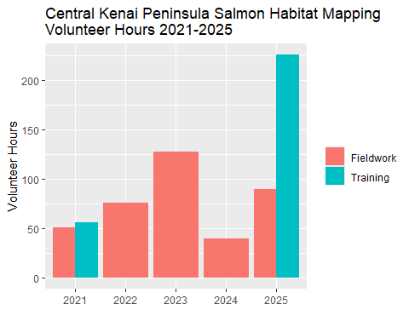

The level of volunteer participation, along with experience gained, mostly tracked the quantity of nominations submitted each year, with a steadily rising number of nominations from 2021 to 2023. 2024 saw very minimal funding resources directed towards fieldwork, thus the number of volunteer hours declined. Despite this reduced funding in 2024, seven nominations were submitted. The result speaks to how sustained financial support, even if fluctuating in amount, is important to keep projects such as this in progress.

In 2025, several training events were held in collaboration with Cook Inletkeeper as part of our shared [Backyard Salmonscapes](https://www.peninsulaclarion.com/news/cook-inletkeeper-program-promotes-community-engagement/) program. Volunteers also contributed efforts to our technical mapping efforts in progress, in collaboration with consultants Terrainworks and Romey Riverscape Sciences. [Click here to read more](https://www.kenaiwatershed.org/news-media/fish-habitat-mapping-2025/) on our new freshwater fish habitat mapping efforts on Kenai Watershed Forum’s website.

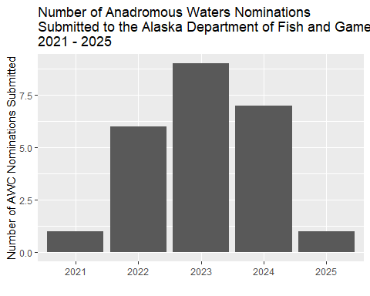

## 3.4 Aquatic Resource Permit

Fish capture data was reformatted each fall in to a csv file for submission to ADF&G in fulfillment of the required [Aquatic Resource Permit](http://www.adfg.alaska.gov/index.cfm?adfg=otherlicense.aquatic_reports)[11]; available in the online in [this project’s GitHub repo](https://github.com/Kenai-Watershed-Forum/tu_awc_expansion/tree/main/output)[12].

# 4. Discussion

Each season of fieldwork was unique, thus we will discuss them individually.

## 4.1 2021

### 4.1.1 2021 Anadromous habitat surveys

In summer 2021 we surveyed sites primarily in the region North of Kenai/Soldotna within an hour’s walking distance of the road system.

Survey site selections were made by visually assessing the superimposed map layers of the Anadromous Waters Catalog with the [USGS National Hydrography Database](https://www.usgs.gov/core-science-systems/ngp/national-hydrography) (NHD)[13]. In areas where previously documented anadromous stream or lake extents ended but connected water bodies continued upstream, we targeted sites suitable for minnow trapping.

At most sites surveyed in 2021, we captured primarily non-anadromous species such as stickleback and sculpin. We also captured some resident salmonid species such as Dolly Varden and Rainbow Trout.

These results supported several conclusions that directed fieldwork efforts following summer 2022:

* A need exists to refine methods for survey site selection. Relying on visual assessment of overlay between documented AWC habitat and the NHD map is frequently insufficient as a prospecting guide for yet-unidentified anadromous waters. Discussions in Fall 2021 with personnel at ADF&G’s Habitat Division in Anchorage yielded valuable insight and potential for collaboration.
* Some drainages in the North Kenai/Nikiski area that may have been historically anadromous have man-made barriers to fish passage that we identified in Summer 2021. One such example was previously undocumented as was discovered by TU volunteers, discussed further in the section below, “Highlight: Habitat Connectivity.” Identifying fish passage barrier sites is a critical first step in determining if restoration is feasible.

#### 4.1.1.1 2021 Highlight: Lower Soldotna Creek Tributary

KWF was notified of a previously undocumented tributary segment in the Soldotna Creek drainage in July 2021. The tributary was documented as anadromous up to a road crossing approximately 100 m upstream from the Soldotna Creek mainstem, but the stream channel continued beyond. The stream segment upstream of the road crossing had been excavated in June 2021 as part of a new residential development project, but it was suspected that the modified channel still supported fish populations. KWF staff placed minnow traps at the most upstream locations where the traps could still be submerged. Over the course of several site visits we captured a total of 65 Coho Salmon and five Dolly Varden.

KWF submitted these data in ADFG’s September 2021 call for data, and documented the approximate paths of existing stream channels, supported by several dozen ground-truthing photos. These data are displayed in the map figure below, and are also accessible at [ArcGIS Online](https://arcg.is/1XO9n5)[14]).

The post-hoc documentation of this previously unidentified salmon stream after it has been altered emphasizes the need for continued thorough efforts to document anadromous habitat, particularly in watersheds experiencing growth and development. Communication with property owners remains critical to the task of identifying previously undocumented anadromous habitat.

### 4.1.2 2021 Highlight: Habitat Connectivity

In two cases where map interpretation suggested presence of salmonids but we captured none, we visited other locations in the watershed where fish barriers may be present. We found evidence of man-made fish barriers at two locations:

1. Suneva Lake - Suneva Lake lies to the North of Daniels Lake in the Nikiski area. The lake’s surface area is appx 1.0 sq km, and flows directly in to Cook Inlet 0.61 km downstream from the lake outlet. Aerial imagery indicates that littoral is ~95% undeveloped. Littoral parcels are primarily privately owned.

* We conducted sampling events on two separate days at Suneva lake. We captured stickleback and sculpin on both occasions, but no salmonids despite extensive effort.
* We visited the outlet at Suneva lake and discovered two perched culverts installed where the outlet stream crosses Sockeye Avenue (Figure 4.1). The culvert is likely impeding fish passage, as there is a drop of several feet between the stream channel and the culvert outlet.
* A site visit to the mouth of the creek flowing from Suneva Lake at its outlet at Cook Inlet will help determine if the waterway has potential to host anadromous species and may be part of future fieldwork.

|  |
| --- |
| Figure 4.1: Perched culvert near outlet of Suneva Lake, intersection with Sockeye Avenue |

1. Salamatof Creek - Salatamtof Creek lies North of Kenai and South of Nikiski, crossing the Kenai Spur highway. A stream connection of 1.56 km flows from Lower Salamatof Lake to Cook Inlet, and a stream segment of 2.84 km connects the lower lake to Salamatof Lake. We sampled at a site in the stream segment connecting the two lakes on one occasion in Summer 2021 and captured a several hundred sticklebacks, but no salmonids.

* We visited the location where maps indicated that Salamatof Creek crosses the Kenai Spur Highway in August 2021 (Figure 4.2).
* At the road crossing we observed a culvert passage for Salamatof Creek below the highway, but no flowing water. The visible nearby body of water at this location appeared to be lotic in nature, and no outflow was readily evident.

|  |
| --- |
| Figure 4.2: Salamatof Creek drainange, North of Kenai, Alaska. Red X indicates location of fish passage barrier. |

Based on observations at the road crossing, it is possible that historical construction activities altered the flow path of Salamatof Creek such that it no longer connects to Cook Inlet except at very high flow volumes. A review traditional knowledge in this area could help reveal if this watershed may have previously been an anadromous waterbody. Additionally, a review of historical aerial imagery could reveal how channel path or lake acreage extent may have changed in recent decades.

### 4.1.3 2021 Outreach and other activities

In addition to fieldwork efforts aimed at prospecting for unidentified anadromous waters, having personnel mobilized and trained in juvenile fish identification and capture methods allowed for support in two additional efforts:

* **Education**. In 2021 KWF oversaw 12 fish sampling events aimed exclusively at education and outreach, occurring primarily at Lower Soldotna Creek. These events introduced basic facts about wild salmon life history and habitat to local community members, visitors, journalists, and summer campers. Total participants is estimated in excess of one hundred people.
* **Culvert replacement**. In summer 2021 KWF oversaw construction activities to replace the culvert carrying the North Fork of the Anchor River underneath Niklovaesk road in the Anchor Point area. As part of these efforts, a small segment of river channel is temporarily de-watered thus fish in this segment must be captured and released downstream prior. KWF personnel was able to capture juvenile fish (n = 329) as part of these fish rescue efforts.

## 4.2 2022

### 4.2.1 2022 Anadromous Habitat Surveys

In Summer 2022 we focused our survey efforts on streams in the Kenai/Soldotna/Sterling area including Coal Creek, Beaver Creek, and tributaries of the Moose River. Experience from the previous season contributed to much more frequent success of identifying anadromous habitat prior to fieldwork. **In 2022, four out of five site visits yielded fish observations used in AWC nominations.**

In one case, at the “Moose River Trib 1.4” site, the flow line indicated by the National Hydrography Database stops ~0.3 miles downstream of the location where we captured juvenile coho salmon. Thus, this salmon-bearing location was not only not documented in the Anadromous Waters Catalog, it was not yet documented even as a stream (Figure 4.3.)

These observations highlight the need for a more sophisticated mapping approach to generate survey sites for additional fieldwork. For additional discussion and a plan forward on this topic, see the “Future Directions” chapter.

|  |
| --- |
| Figure 4.3: An undocumented anadromous tributary of the Moose River near Sterling, AK. |

### 4.2.2 2022 Outreach and other activities

* **Education**. In 2022 KWF continued to oversee fish sampling events aimed exclusively at education and outreach, occurring primarily at Lower Soldotna Creek. These events introduced basic facts about wild salmon life history and habitat to local community members, visitors, journalists, and summer campers. Total participants is estimated in excess of one hundred people.

## 4.3 2023

### 4.3.1 2023 Anadromous Habitat Surveys

In 2023 we continued to focus on waters near the road system in the central Kenai Peninsula including Soldotna Creek, Moose River, Beaver Creek, and smaller unnamed tributaries of the lower main stem Kenai River. **In 2023 nearly all sites that we surveyed revealed the presence of previously undocumented juvenile anadromous fish.**

As presented in the results section, steadily increasing volunteer participation tracked closely with an increasing number of nominations.

### 4.3.2 2023 Outreach and other activities

* **Education**. In 2023 KWF continued to oversee fish sampling events aimed exclusively at education and outreach, occurring primarily at Lower Soldotna Creek. These events introduced basic facts about wild salmon life history and habitat to local community members, visitors, journalists, and summer campers. Total participants is estimated in excess of one hundred people.

## 4.4 2024

### 4.4.1 2024 Anadromous Habitat Surveys

In 2024 nearly all sites surveyed throughout the Kenai Peninsula revealed the presence of juvenile anadromous fish. We focused efforts on streams and lakes in Turnagain Pass, Soldotna, and Sterling. With this year’s field data, Kenai Watershed Forum and it’s volunteers submitted six new nominations.

Post-season, KWF selected several dozen additional locations in the central Kenai Peninsula that would be appropriate for field surveys based on criteria described in the Methods section. We visually assessed the overlay of the National Hydrography Database, the 2024 Anadromous Waters Catalog, and the borough property ownership boundaries layer to select sites. While this is approach is not systematic, it is targeted towards accessible sites where nominations would yield high conservation value. These sites may be viewed in the ArcGIS Online [Project Map](https://bit.ly/kwf_awc) linked here and in the footnote[15].

### 4.4.2 2024 Outreach and other activities

* **Education**. In 2024 KWF continued to oversee fish sampling events aimed at education and outreach, occurring primarily at Lower Soldotna Creek. These events introduced basic facts about wild salmon life history and habitat to local community members, visitors, journalists, and summer campers. Total participants is estimated in excess of two thousand people, primarily from the [Kenai River Fair](https://www.peninsulaclarion.com/news/kenai-river-fair-debuts-with-array-of-activities-and-education/) on June 8th. At this event we displayed juvenile fish in glass aquariums and provided education materials and perspectives to passers-by (Figure 4.4). We also held a similar display at Trout Unlimited Alaska’s riparian restoration event at Centennial Park in Soldotna on June 9th (“[Plants for Salmon](https://www.kdll.org/community-calendar/event/plants-for-salmon-18-05-2024-00-08-49).”)

|  |
| --- |
| Figure 4.4: Juvenile fish from Soldotna Creek displayed in glass aquariums at the 2024 Kenai River Fair at Soldotna Creek Park. |

* **Fish Map App.** In 2024, Kenai Watershed Forum and it’s volunteers submitted all anadromous waters nominations using the [Fish Map App](https://www.alaskafishmapping.org/)[16], a smartphone application developed by a coalition led by the Alaska Conservation Foundation and Indiginous Sentinels Network. The app streamlines the process of recording and preparing field data for Alaskan anadromous water nominations. For each successfully submitted nomination, participants receive a $100 honorarium.
* **New Grant Proposal.** Kenai Watershed Forum was invited to submit a proposal to the [National Coastal Resilience Fund](https://www.nfwf.org/programs/national-coastal-resilience-fund) to continue and substantially expand the work described in this report. The proposal highlighted the conservation and infrastructure values of documenting anadromous habitat, and how current legal infrastructure at the both the State of Alaska level (statute 16.05.871) and Kenai Peninsula Borough (ordinance 21.18) can help ensure that planners and permit reviewers have better maps for decision making. KWF will be notified in winter 2024 if the proposal is funded.
* **Electrofishing Training.** Two Kenai Watershed Forum staff attended a three-day workshop in Anchorage, AK hosted by the Alaska Chapter of the American Fisheries Society and the Alaska Department of Fish and Game. Staff learned principles of safely using electrofishing tools to survey freshwater streams and lakes, culminating with hands-on field experience.
* **GIS Training.** One Kenai Watershed Forum staff member attended a free two-day workshop hosted by [Chickaloon Village Traditional Council](https://www.chickaloon-nsn.gov/) at Alaska Pacific University focused on GIS mapping techniques for fish habitat and fish passage. The course provided immediate value to work described in this project to expand the anadromous waters catalog, with practical workflows to manipulate and measure stream layers and communicate results.
* **Local Habitat Ordinance Updates.** Kenai Watershed Forum, along with othe local nonprofits, communicated throughout 2024 with staff from Kenai Peninsula Borough regarding updates to waterbodies managed under borough ordinance 21.18. By statute, the map of 21.18 waterbodies is to be updated ever three years. However, ten years had passed since the previous update. In response, borough staff began reviewing data hosted in ADF&G Anadromous Waters Catalog to verify currency and detail. Where data is sufficiently robust to document presence of anadromous fish, a package proposal to update the 21.18 maps are received for vote by the borough assembly after review by the Lands Committee. In August 2024 these updates were unanimously adopted by the assembly for the southern district of the borough. Updates to the other two borough andromous habitat districts (Northern and Western) are currently in progress. A map of KPB 21.18 districts can be found [here](https://geohub.kpb.us/datasets/KPB::kpb-21-18-districts/explore).

### 4.4.3 Predictive Habitat Mapping

As previous years discussion sections have highlighted, the geographic scale of efforts needed to map Alaska’s anadromous waters is so large that continuing to rely on ground-truthing efforts alone will result in additional habitat being disturbed before it is even documented (see 2021 Discussion, “2021 Highlight: Lower Soldotna Creek Tributary.”) Additional rationale and background for this discussion can be found in the two essays posted on Kenai Watershed Forum’s blog post, “[Mapping Alaska’s Salmon Streams](https://www.kenaiwatershed.org/news-media/mapping-alaskas-salmon-streams/)[17].” Two efforts were initiated in 2024 to begin to address the challenge:

1. **Gradient Barrier Mapping.** Kenai Watershed Forum and [St. Mary’s University of Minnesota Geospatial Services](http://www.geospatialservices.org/) developed a custom approach in ArcGIS Pro to estimate the locations of probable barriers to upstream migration of adult anadromous fish. Following discussion with Alaska Department of Fish and game staff, we used the National Hydrography Database and available LiDAR data to locate the first point upstream with a 16% gradient over 35m distance for all watersheds in the Kenai Peninsula Borough (KPB). We presumed that all stream and lake habitat downstream from these points may be anadromous. With this approach, we estimated a total of 16,474 miles of anadromous stream habitat, a quantity more than three times the 4,898 miles of currently documented miles of anadromous streams in the KPB.

* While the above approach is relatively coarse, it highlights the scale of probable undocumented anadromous habitat remaining in the KPB region. Further exploration of this dataset is needed to assess its overlay with known existing anadromous habitat.

1. **End-of-anadromy mapping**. In 2024, the Kenai Peninsula Chapter of Trout Unlimited received an additional Embrace-a-Stream grant to explore remote sensing and analysis innovations around the topic of mapping anadromous waters in the Kenai region. We worked with consultants [Romey Fisheries and Aquatic Science](https://www.rom3y.com/) to apply “End-of-Anadromy” modeling to watersheds within the boundaries of the Chugach National Forest, following an approach described for watersheds in southeast Alaska (Romey and Martin 2022). In this approach, a multivariate statistical model of landscape and watershed parameters is applied to predicting probable end-of-anadromy locations rather than a single gradient over distance metric. The approach has proven very successful in southeast Alaska, with researchers able to predict the locations of upper extent of anadromy with 98% accuracy with an average error distance of < 67m. We used juvenile coho salmon as the model species.

The predictive habitat maps discussed above are **not** currently published online in Kenai Wateshed Forum’s ArcGIS Online account, but are available by emailing hydrology (at) kenaiwatershed.org.

Overall, we found that the end of anadromy model that was developed in southeast Alaska did not perform to adequate standards when directly transferred to Kenai region geography. There are likely two main reasons for this result:

* Lack of appropriate region-specific model training data. The Kenai modeling effort was based primarily off of fish distribution parameters developed from field surveys performed in southeast Alaska. It is likely that a suite of geographic characteristics unique to southeast Alaska are responsible for spatial distribution, as is the case for the Kenai region. Thus, transferring model parameters from one regional population to another risks misalignment of geographical and biological data. To remedy this issue, anadromous waters surveys in the Kenai region should be conducted following Last Fish Observed protocols (surveying for fish presence/absence in upstream direction until none observed). These data will then be used to train an updated Kenai-specific regional fish distribution model.
* Different regional fish populations are adapted to distinct regional geographies. Habitat conditions beyond geographical form also influence fish distribution, and are regionally unique. Environmental drivers relevant to habitat modeling can include water temperature regime, stream flow regime, inter species and intra species competition, and water quality. Model performance will improve by using Kenai-region specific datasets.

An anecdotal example of model under performance for both Gradient Barrier as well as End-of-Anadromy mapping is evident in the segment of Granite Creek in Turnagain Pass nominated in 2024 (Figure 3.1). In this figure, a 4.23 km length of Granite Creek is nominated. However, both predictive maps show probable end of anadromous habitat ending near the Hope Highway cutoff, more than 15 stream kilometers downstream from where we observed anadromous fish. Many other similar examples are evident upon examination, highlighting the need to improve existing predictive maps for the Kenai region.

## 4.5 2025

The year 2025 was marked by the award of a major grant from the National Coastal Resilience Fund. In spring 2025, we initiated a collaboration with consultants Terrainworks and Romey Riverscape Sciences to explore using predictive habitat modeling to identify the extent of probable anadromous habitat. Further details about these efforts can be accessed on our website at <https://www.kenaiwatershed.org/news-media/fish-habitat-mapping-2025/>. A full draft-in-progress of methods and scope for this effort is available in a Google Doc; [Mapping Anadromous Habitat in the Kenai Peninsula Borough Project Manual 2025 - 2027 [DRAFT]](https://docs.google.com/document/d/1sJe2g893Urh1uhxVKh1RBIGE8733W4yfJP6w0fgwE0Q/edit?tab=t.0).

## 4.6 Media highlights

### 4.6.1 Radio

From 2021-2023, KDLL Public Radio published three stories about the work discussed in this report:

* [“Groups put area’s anadromous fish on the map”](https://www.kdll.org/local-news/2021-05-28/groups-put-areas-anadromous-fish-on-the-map) (May 27, 2021), reporter Elizabeth Earl
* “[Stream by stream, volunteers map the Kenai Peninsula’s anadromous waters](https://www.kdll.org/local-news/2022-09-02/stream-by-stream-volunteers-map-the-kenai-peninsulas-anadromous-waters)” (September 2, 2022), reporter Sabine Poux (Figure 4.5)
* [“‘They don’t necessarily look like salmon habitat’; Kenai Watershed Forum maps the Peninsula’s anadromous waters”](https://www.kdll.org/local-news/2023-09-18/they-dont-necessarily-look-like-a-salmon-habitat-kenai-watershed-forum-maps-the-peninsulas-anadromous-waters) (September 18, 2023), reporter Hunter Morrison

|  |
| --- |
| Figure 4.5: KDLL Radio Story from September 2, 2022 |

### 4.6.2 Print Media

* [Cook Inletkeeper Program Promotes Community Engagement](https://www.peninsulaclarion.com/news/cook-inletkeeper-program-promotes-community-engagement/) (Peninsula Clarion, November 1, 2025)

### 4.6.3 Public Lecture

On November 1, 2023, Alexa Millward (Trout Unlimited) and Benjamin Meyer (Kenai Watershed Forum) were featured to present this project as part of Kenai Watershed Forum’s “Fireside Chats” series held at Kenai River Brewing in Soldotna, AK.

* Presentation slides [available online at this link](https://docs.google.com/presentation/d/1uQX9_4T-vJDzp_gzBJFyqtggOg1Fpsng?rtpof=true&usp=drive_fs)
* Audio lecture [available at this link](https://www.kdll.org/podcast/kenai-conversation/2023-11-15/kenai-conversation-mapping-anadromous-waters), aired on KDLL Radio’s Kenai Conversation on November 15, 2023

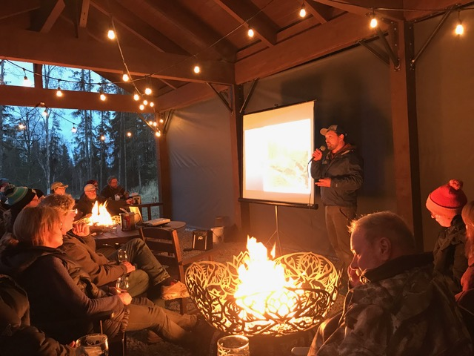

# 5. Future Directions

|  |
| --- |
| Figure 5.1: Figure from ‘Southeast Alaska Fish Habitat,’Romey Fisheries and Aquatic Sciences (2021)’. Color gradients indicate relative probability of anadromous fish presence. |

## 5.1 Summary

|  |  |
| --- | --- |
|  | Our on-the-ground work serves to strengthen local freshwater habitat conservation and education efforts. However given the likely quantity of remaining undocumented anadromous habitat, going forward it will be critical to use a systematic, targeted fieldwork approach that can inform models for predictive occupancy maps that could one day be used for habitat regulation and management. |

The collaboration between the local nonprofits Kenai Peninsula Chapter of Trout Unlimited, Cook Inletkeeper, and Kenai Watershed Forum serves as a compelling example of how to engage volunteers interested in conserving fish habitat with hands-on opportunities. There is great potential to expand and continue the work described in this report, and a great urgency to do so.

The anadromous waters nominations generated as a result of this project will play an important role in conserving salmon habitat in the areas we surveyed. The value of educating and engaging volunteer participants is also evident. However the broader take away from this project is the need to re-frame our approach for how to discover, document, and conserve Alaska’s anadromous habitat. Our current methods would continue to yield annual AWC nominations, but at a scale and pace insufficient to keep pace with new developments, even with many additional volunteers. The potential to accelerate this work and identify thousands of additional anadromous stream miles on the Kenai Peninsula is ready at hand, and much of the initial groundwork has already been completed and is awaiting financial support.

Ultimately, the driving force behind the work described in this report is the presumption that Alaska freshwater habitat is **not** anadromous, unless anadromous fish have been physically documented. Our results strongly indicate the value of revising this assumption. The relative ease with which we documented over twenty four miles of anadromous stream and nearly two hundred lake-acres adjacent to a growing developed area suggests that even our most sincere efforts to ground-truth the presence/absence of anadromous fish will dramatically underestimate their range. In the past, the presumption of non-anadromy may have served to manage the larger, more visually apparent rivers and lakes where adult fish migrate and spawn, but for smaller headwaters and tributaries it puts untold quantities of juvenile rearing habitat at existential risk.

How can we address this risk without putting undue burden on state agency managers, researchers, and permit specialists? It would be ideal if we could easily document each and every end-of-anadromy headwaters location, but given that the physical geography of watersheds is that of a tree-shaped fractal network with progressively smaller upstream headwaters (Carraro and Altermatt 2022), it is not a realistic goal. The number of such locations in the Kenai Peninsula Borough alone might number tens of thousands. If we wish to understand the full picture of where fish actually occupy the landscape, clearly another approach is needed.

Today, researchers are developing predictive models that can represent fish occupancy on the freshwater landscape with a high level of accuracy. These models are discussed in further detail below, and also in an essay on Kenai Watershed Forum’s website [(“Mapping Alaska’s Salmon Habitat.)”](https://www.kenaiwatershed.org/news-media/mapping-alaskas-salmon-streams/) Currently these models are regionally-focused. In the future, if a successful predictive model can be scaled to the state-wide level, managers and permit specialists may be able to use these maps when reviewing the impacts of proposed development projects. If adopted, such an approach would provide a level of detail that more accurately represents the true range of freshwater fish habitat. As outlined in the 2024 Discussion section, habitat intrinsic potential models transferred from southeast Alaska to the Kenai region underperformed. Additional region-specific data to train these models will likely create much higher degrees of predictive accuracy.

## 5.2 Rationale for Anadromous Waters Mapping in Alaska

As described in Section 1.2 of this report, current Alaska statute is such that rivers, streams, and lakes throughout Alaska are presumed non-anadromous until otherwise demonstrated, thus the need for the hands-on documentation such as that featured in this project. A failed statewide ballot measure initiative in 2018 would have reversed the baseline presumption of non-anadromy, among other changes to salmon habitat regulations[18].

Various state, federal, tribal, private, and non-profit entities have pursued the work of documenting anadromous habitat for decades and contributed to the detail contained within the anadramous waters catalog. When anadromous habitat is undocumented, proposed development on or near these waters will not necessarily trigger the need for a Fish Habitat Permit review from ADF&G, which requires impacts to be evaluated along with possible local mitigation requirements such as fish-friendly culverts or enforcement of riparian buffer zones.

This dearth of detailed map information has had consequences particularly in rapidly developing areas. For example, in Summer 2021 a tributary Soldotna Creek was partially excavated and ditched, and was not documented as anadromous until after the fact[19]. Arguably, this outcome would have been less likely had managers or the developer been aware that this salmon stream existed. Another prominent example is when in 2008-2010, dozens of anadromous streams were documented and nominated by The Nature Conservancy directly within the proposed footprint of Pebble Mine; waters that had not been documented by mine consultants conducting baseline assessments[20],[21]. Thus the sooner that currently undocumented anadromous waters are documented, the more likely it is that impacts can be properly evaluated and mitigated prior to development.

## 5.3 Current State of Anadromous Waters Mapping

As described in section 2.1 of this report (Methods: Site Selection), most current fieldwork efforts are prioritized by visually assessing the overlap of stream segments in the Anadromous Waters Catalog and the National Hydrography Database. Communication among regional researchers and managers also helps choose fish survey locations, along with suggestions from the general pubic. Researchers have also used formal oral interviews with traditional knowledge holders to help suggest fish survey locations[22].

While all these methods are useful in generating ideas for survey locations, they do not comprise a systematic approach and they are based on incomplete stream network maps. In order for conservation needs to better match the pace of conservation challenges, a more comprehensive approach is needed.

Some efforts toward this end have been initiated in recent years. In the southern Kenai Peninsula, researchers with Kachemak Bay National Estuarine Research Reserve (KBNERR) successfully applied a predictive habitat modeling approach in a study from 2012 ([King et al. 2012](https://www.journals.uchicago.edu/doi/abs/10.1899/11-109.1))[23] and added dozens of miles to the AWC from resulting efforts. However, the approach taken by the KBNERR researchers would arguably prove challenging to replicate at broader geographic scales, as it relies on extensive ground truthing of habitat characteristics and flow to produce the predictive models.

Another similar approach to anadromous habitat mapping is currently being applied in southeast Alaska by the U.S. Forest Service and other partners. Using high resolution stream network maps coupled with fish habitat intrinsic potential models, researchers are able to predict the locations of upper extent of anadromy with 98% accuracy with an average error distance of < 67m[24]. For more details see the [StoryMap from Romey Fisheries and Aquatic Sciences](https://storymaps.arcgis.com/stories/6b3949e1ebcd44c6a531d13f038807c5)[25].

Predicting the locations of upper anadromous extent allows researchers to take a more informed approach to prioritzing their fieldwork of documenting anadromous habitat. Researchers in southcentral Alaska should aspire to emulate the approach described in the preceding StoryMap, prioritizing surveys of waters outside the federally managed areas of the Kenai National Wildlife Refuge and Chugach National Forest.

For future long-term efforts to effectively gather field data to be used in AWC nominations, two general research directions are suggested:

1. Application of higher-resolution stream network maps and habitat modeling approaches, such as [NetMap](https://www.fs.usda.gov/pnw/tools/netmap)[26]
2. Evaluation of “success rates” in prospecting for anadromous sites. E.g., how frequently, when, and where do predictions undocumented anadromous habitat prove correct?
3. Formal and frequent communication and collaboration among entities conducting anadromous habitat survey work

The combination of these approaches outlines a collaborative approach to AWC mapping, where remote sensing data is used to make predictions that are then refined by field observations.

Given the near-perfect rate of predictions thus far using the predictive modeling approach in southeast Alaska, in the future these maps of stream segments *predicted* to be anadromous might be used by managers when evaluating environmental impacts and the need for permitting and mitigation – pending continued model refinement, public education and support, and acceptance by regulators.

For further discussion on the topic of anadromous waters mapping in Alaska, visit Kenai Watershed Forum’s website to read the post, [“Mapping Alaska’s Salmon Streams.”](https://www.kenaiwatershed.org/news-media/mapping-alaskas-salmon-streams/)

## 5.4 Next Steps

To follow though on the recommendations above, a dedicated research project is being developed and executed in cooperation with subject experts. The following steps describe a path forward:

1. **Evaluate existing NetMap coverage for the Kenai Peninsula Borough**
   * NetMap was commissioned for the Chugach National Forest in 2017, and Kenai Peninsula coverage extends from the Prince William Sound / Turnagain Arm region to the western boundary with Kenai National Wildlife Refuge. The shapefiles are available by contacting Kenai Watershed Forum or Romey Fisheries and Aquatic Sciences.
   * LiDAR, a geospatial dataset needed to produce the NetMap stream layers, already has complete coverage for the Kenai Peninsula Borough region.
   * This work is in progress as of Fall 2024, see 2024 Discussion section.
2. **Develop, communicate, and maintain a prioritized list of fish habitat survey sites shared among multiple agencies**
   * Once a list of locations of predicted Upper Extent of Anadromy is generated using the NetMap layer, regional experts can use their knowledge of local conservation priorities to prioritize which sites should be surveyed first. This step will involve both a GIS based approach for tasks such as identifying parcel ownership status where sites are located, as well as a consensus/discussion based approach to apply knowledge of local conservation priorities and planning efforts.
   * Site survey responsibilities will be assigned to participating organizations. Once complete, preliminary results will be recorded in a shared database to minimize redundant site visits.
3. **Recruit and train participants from agency employees and volunteers**
   * Entities known to currently be engaged in the work of AWC nominations in the Kenai Peninsula region include the following, but are not limited to:
     + Alaska Department of Fish and Game Habitat Division
     + Kenai Soil and Water Conservation District
     + U.S. Fish and Wildlife Service
     + Kenai Watershed Forum
     + Kachemak Bay National Estuarine Research Reserve
     + Kenai Peninsula Chapter of Trout Unlimited
     + University of Alaska
   * Training sessions would be offered to encourage participation from the general public
   * Employing a consistent, user-friendly, collaborative method of data collection will be critical to implementing this project on a larger scale. ADF&G requires that AWC nominations are supervised by a “qualified biologist,” thus careful and systematic review of nomination data prior to submission will be essential. Use of a custom-designed ESRI Survey123 app is likely the most appropriate choice for this task. The smartphone app “[Fish Map App](https://alaskafishmapping.org/)”[27] developed by the [Indiginous Sentinals Network](https://www.sentinelsnetwork.org/) also shows potential to be highly useful in this process; though currently the app is not yet designed to record some essential information for juvenile surveys, such as gear effort.
   * A high degree of location accuracy (<1m) is required for ground-truthing NetMap data. Expensive options such as Trimble hand held devices may be inaccessible, thus it is suggested to train participants to use bluetooth accessory receivers (e.g. [Bad Elf GNSS Surveyor](https://bad-elf.com/pages/be-gps-3300-detail)) when recording coordinates.

Many other regions of Alaska have already had synthetic stream networks developed and mapped. Following the success of the work proposed above, the approach would be able to be replicated state-wide.

## 5.5 Final Words

While this report shows how much has been accomplished in documenting local salmon habitat, it is clearer than ever how much remains to be accomplished. We are grateful for the help and support of the dozens of volunteers involved with making this project happen and we look forward to continuing our efforts together.

# References

Bateman, Douglas S., Robert E. Gresswell, and Christian E. Torgersen. 2005. “Evaluating Single-Pass Catch as a Tool for Identifying Spatial Pattern in Fish Distribution.” *Journal of Freshwater Ecology* 20 (2): 335–45. <https://doi.org/10.1080/02705060.2005.9664974>.

Carraro, Luca, and Florian Altermatt. 2022. “Optimal Channel Networks Accurately Model Ecologically-Relevant Geomorphological Features of Branching River Networks.” *Communications Earth & Environment* 3 (1): 1–10. <https://doi.org/10.1038/s43247-022-00454-1>.

Penaluna, Brooke E., Jennifer M. Allen, Ivan Arismendi, Taal Levi, Tiffany S. Garcia, and Jason K. Walter. 2021. “Better Boundaries: Identifying the Upper Extent of Fish Distributions in Forested Streams Using eDNA and Electrofishing.” *Ecosphere* 12 (1): e03332. <https://doi.org/10.1002/ecs2.3332>.

Reynolds, Jim, and Lisa Harlan. 2011. “Quick-Start Guide to Electrofishing.” <https://www.smith-root.com/images/smith-root/downloads/00261_quick_start_guide_to_electrofishing.pdf>.

Romey, Bernard, and Douglas Martin. 2022. “Landscape-Level Extent of Resident Fish Occupancy in the Alexander Archipelago.”

Torgersen, Christian E, Robert E Gresswell, and Douglas S Bateman. 2004. “Pattern Detection in Stream Networks: Quantifying Spatial Variability in Fish Distribution.” In, 2:405–20. <https://citeseerx.ist.psu.edu/document?repid=rep1&type=pdf&doi=53c09421570e75b391f9b7b9e2f53124eeeeae59>.

1. <http://www.adfg.alaska.gov/index.cfm%3Fadfg=habitatregulations.prohibited>
2. <https://www.adfg.alaska.gov/sf/SARR/AWC/index.cfm?ADFG=main.home>
3. <https://www.adfg.alaska.gov/sf/SARR/AWC/index.cfm?ADFG=nomSubmit.about>
4. <https://paperpile.com/shared/sjm~9ORhFQSmRxQx6f0JVpg>
5. <https://bit.ly/kwf_awc_sop>
6. <https://www.kenaifishpartnership.org/cap/>
7. <https://arcg.is/01mHjP>
8. <https://bit.ly/eas_data>
9. <https://github.com/Kenai-Watershed-Forum/salmon-habitat-mapping>
10. <https://bit.ly/tu_kwf_embrace_a_stream_2021>
11. <http://www.adfg.alaska.gov/index.cfm?adfg=otherlicense.aquatic_reports>
12. <https://github.com/Kenai-Watershed-Forum/tu_awc_expansion/tree/main/output>
13. <https://www.usgs.gov/core-science-systems/ngp/national-hydrography>
14. https://arcg.is/1XO9n5
15. <https://bit.ly/kwf_awc>
16. <https://www.alaskafishmapping.org/>
17. <https://www.kenaiwatershed.org/news-media/mapping-alaskas-salmon-streams/>
18. <https://ballotpedia.org/Alaska_Ballot_Measure_1,_Salmon_Habitat_Protections_and_Permits_Initiative_(2018)>
19. <https://bookdown.org/kwfwqx/awc_expansion/discussion.html#highlight-soldotna-creek-tributary>
20. <http://www.pebblescience.org/pdfs/FishSurveysinNushagak%20and%20Kvichakheadwaters.pdf>
21. <https://www.adn.com/alaska-news/article/salmon-documented-streams-top-pebble-prospect/2011/04/27/>
22. Personal communication with Duncan Green, Alaska Department of Fish and Game, February 21, 2022
23. <https://www.journals.uchicago.edu/doi/abs/10.1899/11-109.1>
24. <https://paperpile.com/app/p/e21bfd9e-9b5a-0237-ad38-12b73fbdccbb>
25. <https://storymaps.arcgis.com/stories/6b3949e1ebcd44c6a531d13f038807c5>
26. <https://www.fs.usda.gov/pnw/tools/netmap>
27. <https://alaskafishmapping.org/>